**Joewed E. Villanueva**

**BSIT-3101-SM**

**Laboratory 2**

**Code:**

<html>

<body>

<h2>Text Input</h2>

<form>

First name:<br>

<input type=”text” name=”firstname”>

<br>

Last name:<br>

<input type=”text” name=”lastname”>

<br>

Gender:<br>

<input type=”radio” name=”gender” value=”male” checked> Male<br>

<input type=”radio” name=”gender” value=”female”> Female<br>

<input type=”radio” name=”gender” value=”other”> Other

</form>

<p>Note that the form itself is not visible.</p>

<p>Also note that the default width of a text input field is 20 characters.</p>

<br>

<input type=”submit” value=”Submit”>

</body>

</html>

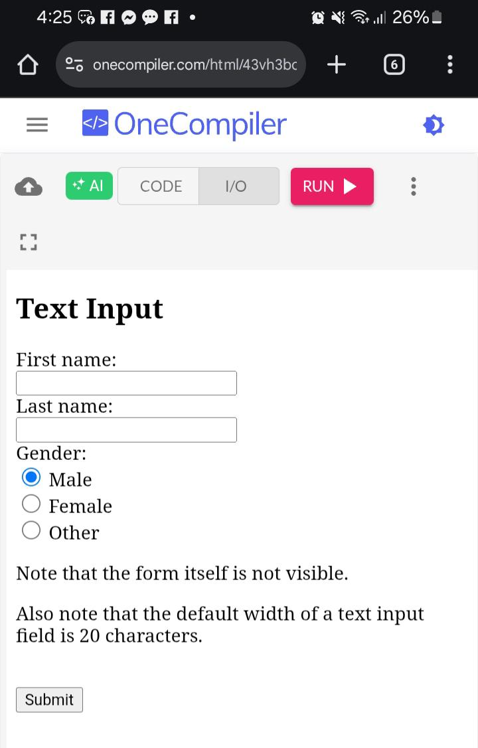

**Result:**